Underway pH
An automated underway pH system was operated in the hydro lab of the R/V Ronald H. Brown during the A13.5 cruise in 2010. pH was measured every 30 seconds using a Durafet III pH combination electrode and an Orion Chloride Ion Selective Electrode (Cl-ISE). This combination allows for the calculation of pH using two reference electrodes: the internal reference electrode of the Durafet (pH_{int}) and the Cl-ISE directly submersed in seawater (pH_{ext}). pH is reported on 30 second intervals to provide the maximum flexibility for assessing precision and capturing small scale features in the ocean. Seawater continually flowed through a flowcell that housed the Durafet and Cl-ISE, then a SBE45 Micro Thermosalinograph. The temperature inside the flowcell was assumed to be the same as the SBE45. The salinity measurements from the SBE45 were not reliable on this cruise (based on comparisons with discrete bottle samples), therefore salinity from the SBE45 located next to the underway fCO₂ system [Wanninkhof, 2012] was interpolated onto the pH time stamp. Latitude, longitude, and sea surface temperature (SST) were also interpolated from the underway fCO₂ data set. All pH is reported on the total scale, and at SST. All data reported here are considered “good”. We recommend the use of pH_{ext}, as we believe this is more accurate than pH_{int}.
Details on the sensor theory and calculations can be found in [Martz et al., 2010; Bresnahan et al., 2014], but will be briefly described here. Computation of pH_{ext} requires knowledge of two sensor calibration coefficients, the sensor reference potential at 0 °C ${(E}_{ext,0°C}^{*})$ and the temperature coefficient $\left(\frac{dE_{ext}^{*}}{dT}\right)$:
 | $${pH}_{ext}= \frac{\left(E_{ext}-E_{ext}^{*}\right)+S×log⁡(γ_{H}γ_{Cl}m_{Cl})}{S}$$ | (1)
 | $$E_{ext}^{*}=E_{ext,0°C}^{*}+\frac{dE_{ext}^{*}}{dT}T$$ | (2)
where E_{ext} is the electromotive force between the ISFET and the Cl-ISE, $E_{ext}^{*}$ is the reference potential at in situ temperature, T is temperature in Celsius, γ is the activity coefficient of the respective ions, m_{Cl} is the molality of chloride, and S = R×T_{K}×ln(10)/F (R is the universal gas constant 8.3145 J K⁻¹ mol⁻¹, T_{K} is temperature in Kelvin, and F is the Faraday constant 96485 C mol⁻¹). S, $γ_{H}γ_{Cl}$, and $m_{Cl}$ are calculated from measurements of temperature and salinity [Khoo et al., 1977; Dickson et al., 2007; Martz et al., 2010]. A linear regression between $E_{ext}^{*}$ and T gives $E_{ext,0°C}^{*}$ (intercept) and $\frac{dE_{ext}^{*}}{dT}$ (slope). $\frac{dE_{ext}^{*}}{dT}$ was determined to be -957 ± 8 (95% CI) µV °C⁻¹.
Computation of pHint requires knowledge of two sensor calibration coefficients, the sensor reference potential at 0 °C ${(E}_{int,0°C}^{*})$ and the temperature coefficient $\left(\frac{dE_{int}^{*}}{dT}\right)$:
 | $${pH}_{int}= \frac{\left(E_{int}-E_{int}^{*}\right)}{S}$$ | (3)
 | $$E_{int}^{*}=E_{int,0°C}^{*}+\frac{dE_{int}^{*}}{dT}T$$ | (4)
where E_{int} is the electromotive force between the ISFET and the internal reference electrode, $E_{int}^{*}$ is the reference potential at in situ temperature, A linear regression between $E_{int}^{*}$ and T gives $E_{int,0°C}^{*}$ (intercept) and $\frac{dE_{int}^{*}}{dT}$ (slope). $\frac{dE_{int}^{*}}{dT}$ was determined to be -1.127 ± 0.008 (95% CI) mV °C⁻¹.
Both $E_{int}^{*}$ and $E_{ext}^{*}$ can be calculated by measuring E_{int} or E_{ext} in a solution of known pH. Here, we used the surface discrete sample for fCO₂ and dissolved inorganic carbo (DIC) from the rosette at each station to calculate the calibration coefficients (n = 129). $E_{ext,0°C}^{*}$ was determined to be -1.37370 ± 0.0003 (1σ) V. A non-linear drift in $E_{int,0°C}^{*}$ was observed, with a range of approximately 2 mV (Figure 1). In order to account for this drift, a piece-wise linear regression was performed over three sections: 1) before March 21st, 2) between March 21 and 28, and 3) after march 28. pH_{int} was calculated using this interpolated $E_{int,0°C}^{*}$. The cause of this drift is not known, but could be largely corrected for due to the large number of calibration samples.
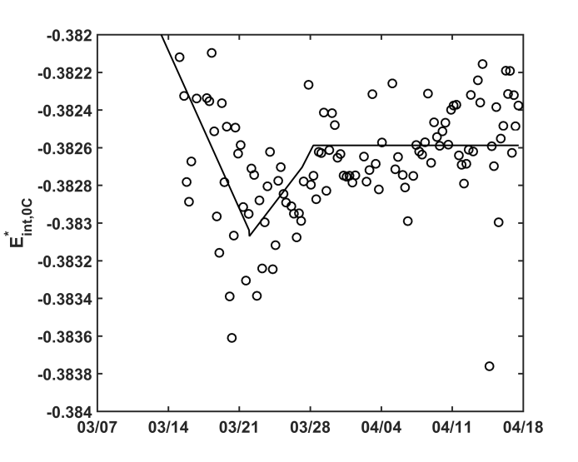
Figure 1: Time series of $E_{int,0°C}^{*}$ (open circles). Piece wise linear regression is shown in the solid black line.
All carbonate calculations were done using CO2SYS [van Heuven et al., 2011], using carbonate equilibrium constants from [Mehrbach et al., 1973] refit by [Dickson and Millero, 1987], salinity to boron ratios from [Uppstrom, 1974], and bisulfate equilibrium constants from [Dickson, 1990].
We believe the underway pH_{ext} is accurate to 0.007, based on the consistency of calibrating the pH sensors using multiple combinations of discrete samples (i.e. fCO₂, total alkalinity, DIC, and spectrophotometric pH). However, the short term precision (hours) and long term precision (weeks) of the underway pH_{ext} data is 0.0005 and 0.004, respectively. Details of the uncertainties associated with pH_{ext} can be found in [Takeshita et al., 2017, in review].
Variable Descriptions
DATE_UTC_ddmmyyyy: Date in UTC, formatted as ddmmyyyy
TIME_UTC_hhmmss: Date in UTC, formatted as hh:mm:ss
LAT_dec_degree: Latitude in decimal degree, interpolated from the underway fCO₂ system
LONG_dec_degree: Longitude in decimal degree, interpolated from the underway fCO₂ system
Eint_volt: Voltage between the ISFET and internal reference electrode
Eext_volt: Voltage between the ISFET and the external reference electrode (Cl-ISE)
TEMP_FLOWCELL_C: Temperature of the flow cell in Celsius
SALINITY_PSS_78: Sea surface salinity based on the PSS-78 practical salinity scale,, interpolated from the underway fCO₂ system
SEA_SURFACE_TEMPERATURE_C: Sea surface temperature in Celsius, interpolated from the underway fCO₂ system
pH_INT_TOT_AT_SST: pH on the total scale at sea surface temperature calculated using the internal reference electrode on the total scale, at SST
pH_EXT_TOT_AT_SST: pH on the total scale at sea surface temperature calculated using the external reference electrode on the total scale, at SST

References
Bresnahan, P. J., T. R. Martz, Y. Takeshita, K. S. Johnson, and M. LaShomb (2014), Best practices for autonomous measurement of seawater pH with the Honeywell Durafet, Methods Oceanogr., 9, 44–60.
Dickson, A. G. (1990), Standard potential of the reaction : AgCl ( s ) + 1/2H2( g ) = Ag ( s ) + HCl ( aq ), and the standard acidity constant of the ion HSO4- in synthetic sea water from 273 . 15 to 318 . 15 K, J. Chem. Thermodyn., 22(3), 113–127.
Dickson, A. G., and F. J. Millero (1987), A Comparison of the Equilibrium Constants for the Dissociation of Carbonic Acid in Seawater Media, Deep Sea Res., 34(10), 1733–1743.
Dickson, A. G., C. L. Sabine, and J. R. Christian (Eds.) (2007), Guide to best practices for ocean CO2 measurements, PICES Special Publication 3.
van Heuven, S., D. Pierrot, J. W. B. Rae, E. Lewis, and D. W. . Wallace (2011), MATLAB Program Developed for CO2 System Calculations. ORNL/CDIAC-105b., , doi:10.3334/CDIAC/otg.CO2SYS_MATLAB_v1.1.
Khoo, K. H., R. W. Ramette, C. H. Culberson, and R. G. Bates (1977), Determination of hydrogen ion concentrations in seawater from 5 to 40.degree.C: standard potentials at salinities from 20 to 45%, Anal. Chem., 49(1), 29–34, doi:10.1021/ac50009a016.
Martz, T. R., J. G. Connery, and K. S. Johnson (2010), Testing the Honeywell Durafet for seawater pH applications, Limnol. Oceanogr. Methods, 8, 172–184, doi:10.4319/lom.2010.8.172.
Mehrbach, C., C. H. Culberson, J. E. Hawley, and R. M. Pytkowicz (1973), Measurement of the apparent dissociation constants of carbonic acid in seawater at atmospheric pressure, Limnol. Oceanogr., 18(6), 897–907, doi:10.4319/lo.1973.18.6.0897.
Uppstrom, L. R. (1974), The boron/chlorinity ratio of deep-sea water from the Pacific Ocean, Deep. Res. Oceanogr. Abstr., 21(2), 161–162, doi:10.1016/0011-7471(74)90074-6.
Wanninkhof, R.H. (2012). Underway measurements of surface partial pressure of CO2 during the R/V Ronald H. Brown Cruise in the Atlantic Ocean on CLIVAR Repeat Hydrography Section A13.5_2010 (March 8 - April 17, 2010). http://cdiac.ornl.gov/ftp/oceans/CLIVAR/A13.5_2010.data/Underway_data/. Carbon Dioxide Information Analysis Center, Oak Ridge National Laboratory, US Department of Energy, Oak Ridge, Tennessee. doi: 10.3334/CDIAC/OTG.CLIVAR_A13.5_2010_UNDERWAY

